ICD Revision Project Plan

Version 2.1

Scope of the document
This document describes the ICD revision process as an overall project plan, in terms of goals, key streams of work, activities, products, and key participants. It informs all contributors of the environment, decisions, architecture, procedures, risks, and open questions. This is a dynamic document which will evolve during the revision process and changes are documented in the revision history with version control.
All TAGs, Workgroups, and additional contributing specialists agree to comply with rules, regulations and workflows that are specified in the most recent version of this document and its annexes.
Organization of the document
The document consists of 3 sections. The first describes goals and refines expected outcome of the Revision. The second section contains the management plan, as budget and tasks. Part 3 contains annexes that provide detail for roles, tasks, workflows, and the budget.

ICD Revision Project Plan 1
Version 2.0 1
Executive summary 5
Introduction 5
Goals for the current ICD revision: ICD-10 to ICD-11 6
Project milestones and budget, and organizational overview 7
Version History 10
List of Acronyms 11
Glossary 12
Section I Goals and structures 13
1 Goals of the ICD Revision Process 13
1.1 National Modifications 13
1.2 Multilingual versions of ICD-11 drafts 14
1.3 Linkage to terminologies and ontologies 14
1.4 Basic Taxonomic Principles and Health Information System 15
1.5 Usecases - Meeting the users needs 16
1.6 Backwards Compatibility 16
1.7 Web based distributed development 17
1.8 ICD Revision Phases: 18
2 Structure of ICD-11 19
Section II- The Management Plan 21
1 Organization & Design of Revision Process 21
1.1 Forming Revision Steering Group (RSG) 21
1.2 Formulating user guide for Topic Advisory Group (TAG) work processes 21
1.3 Forming of TAGs 22
1.4 Forming Work Groups within each TAG 22
1.5 Needs analysis and concepts of core Usecases 23
3 Producing ICD-10 Revision Platform, Information Model (IM), Software and Revision Tools 24
3.1 Producing ICD-Revision Platform 24
3.2 Formulating the Content and Information Model 25
3.2.1 Content Model 25
3.3 Creating iCAT tool 26
3.4 Producing ontology tools for formal representation of disease knowledge 28
3.5 Assembling Revision Platform 28
4 Priming the Platform: The Start-Up List 28
5 Formulating ICD-11 Alpha-draft 33
5.1 Alpha Drafting Workflow 33
5.2 ICD Category Assignment to TAGs 36
5.3 Populating the Content Model 36
5.4 Peer Review Process 36
5.5 Structural Changes 36
5.6 Areas of Overlap & Areas of Conflict 37
5.7 Reviewing by Classification Experts 37
5.8 Commenting by RSG 37
5.9 Harmonization with FIC & ontologies 38
5.10 Incorporating comments 39
5.11 Checking for consistency, continuity, completeness 39
5.12 Writing Alpha-draft ICD-11 report 39
5.13 Pilot testing 39
5.14 Conducting expert consultations 39
6 Formulating ICD-11 Beta-draft 39
7 Field trials focused on usecases 41
7.1 Mortality 41
7.2 Morbidity 41
7.3 Casemix 41
7.4 Quality and patient safety management 41
7.5 Primary care scenarios for activity, quality, and financial administration 42
8 Final draft 42
9 Implementation, Dissemination & Public Health engagement 43
10 Producing multilingual versions 46
11 Project coordination & management 49
I. Budget Summary 50
II. Risks 51

Executive summary

Introduction
The International Classification of Diseases (ICD) is a key instrument of the World Health Organization. Upon the formation of WHO in 1948, ICD was adopted and has been maintained ever since, representing the basis for national and internationally comparable and up-to-date consistent collection, classification, processing, and presentation of disease-related data. ICD was initially developed for coding causes of death. However, continuous evolution now renders ICD useful for coding morbidity, as well as recording specific diseases, injuries, signs, symptoms, complaints, social circumstances, reasons for presentation and external causes of both injury and disease.
ICD informs public health bodies, clinicians and researchers alike in the evolving environment of increasingly complex health systems, ensuring the provision of language and system-independent definitions that are applied for:
- National and international health statistics (mortality and morbidity);
- Epidemiology, surveillance, and monitoring:
- Individual patient records and electronic health records;
- Reimbursement and health system financing;
- Reference for treatment guidelines, scientific literature and research;
- Quality assessment at the level of individual cases up to assessment of health system outcomes and monitoring.
WHO leadership in health information, and the role of ICD was reemphasized in the WHO Nomenclature Regulations that stipulate ICD in its most up to date version is to be used for mortality and morbidity reporting in all Member States.
The success of ICD-10 is unequivocal:
- 70% of the world’s health expenditures (3,500 Billion USD) are allocated using ICD directly for reimbursement and resource allocation;
- 110 countries that collectively account for 60% of the world’s population use cause of death data coded with ICD for health planning and monitoring in a systematic fashion.
- ICD-10 is cited in more than 20,000 scientific articles.
Developing countries bear a large burden of disease with many of their health systems lacking resources in the face of an overwhelming tide of urgent and life threatening demands. Consequently, planning of interventions may be less than optimal and their effectiveness limited accordingly and once established; such vicious circles are an obstacle to achieving the best possible health for a population from an already limited amount of resources. Effective deployment of ICD-derived tools would facilitate the use and collection of health information under such challenging circumstances and therefore facilitate quantitatively informed decisions.
ICD is a core member of the WHO Family of International Classifications. These core classifications form the basis for numerous additional derived & related modifications. WHO owns all rights and processes that relate to ICD and its other core classifications and has the responsibility to ensure conceptual consistency in all the changes that are introduced accordingly.
Historically, ICD is revised approximately every 10 years, with the exception of the 20-year period between the last two revisions, ICD-9 and the most recent version, ICD-10. ICD-10, was completed in 1990 and the WHA requested that it should be revised as necessary, with such revision being organized and coordinated by the WHO Secretariat in order to provide support for the eventual transition from ICD-10 to ICD-11. Below we present the revision goals, the organizational structure and the plan.

Goals for the current ICD revision: ICD-10 to ICD-11
- Update ICD to accommodate new scientific, clinical and public health knowledge
Since ICD-10 was issued, health-related knowledge and related applications have expanded dramatically. For example, progress in biotechnology and genome sequencing and disease gene mapping, novel disease and epidemiology and intervention effectiveness modelling (e.g. GBD, cost-effectiveness), as well as web-driven information sharing and computer-based analysis have widely impacted many aspects of our current understanding and interpretation of health.
- Integration of broad consultations and new, internet-based technologies for information gathering, integration and sharing
The revision has two facets: firstly, building from a backbone of expert reviews and stakeholders’ consultations and secondly, expanding to embrace internet-based technologies enabling knowledge capture from a broader, multi-discipline global community and ensuring effective facilitation of integration with a broad spectrum of health systems.
- Integration and cross-referencing with health-related terminology systems
The current revision links ICD-11 to modern terminology systems that form reference bases for medical definitions and accordingly ensure seamless integration with electronic health information systems.
- Harmonize with ICD-related and derived classifications as well as other members of the WHO Family of International Classifications
Revision of ICD-11 establishes procedures and mechanisms that enable ICD-11 to co-evolve and capture the valuable synergies offered by complementing health information systems, keeping up with fast development of knowledge, and the associated evolution of computer applications and classifications.
- Build in needs-driven adaptations to the revision process around priority ICD Use Cases, including public health mortality and morbidity surveillance, phenotype stability, quality and patient care, financial management applications.
- Accelerate global implementation plans with particular focus on developing countries
ICD-11 implementation success will depend on ease of integration with current applications and other health system technologies and methodologies. Developing countries will not only participate early in the revision process, but also will be able to articulate their specific needs for information presentation and tools that can build capacity for accelerated introduction, implementation, and transition from ICD-10 to ICD-11.

Project milestones and budget, and organizational overview

MILESTONE | ACHIEVED BY | COST | CUMMULATIVE COST
Needs analysis executed | Sep 2008 | $190,000 | $190,000
Revision team is formed | Sep 2009 | $994,000 | $1,184,000
Revision Platform is ready to begin Alpha Drafting | Sep 2009
Revision Platform ready for all types of inputs and outputs | Dec 2012* | $1,500,000 | $2,684,000
ICD Alpha Draft iCAT Training | 22 Sep - 2 Oct 2009 | $100,000
Alpha draft phase I begins | 2 Oct 2009
Alpha-draft Released | May 2010 | $2,115,000 | $9,537,000
Beta- draft released | May 2012 | $1,405,000 | $10,942,000
Field trials completed | July 2012 | $1,590,000 | $12,532,000
Pre-final draft released | Mar 2013 | $725,000 | $13,257,000
ICD-11 endorsed by WHA | May 2014 | $255,000 | $13,512,000
ICD-11 implementation package ready | July 2014 | $2,850,000 | $16,362,000
ICD-11 published in six official languages | Mar 2014 | $6,000,000 | $22,362,000
Pilot countries implemented ICD-11 | Mar 2014 | $13,338,000 | $35,700,000
*functionality for relevant revision work will be available by late 2009/2010. Advanced output functionality will be available for preparation of the pre-final draft
** major input will be ready for the alpha draft. The process allows additional input until beta version for field testing.
Total budget of USD 42,600,000 includes USD 6,900,000 project coordination cost fully supported by the WHO.
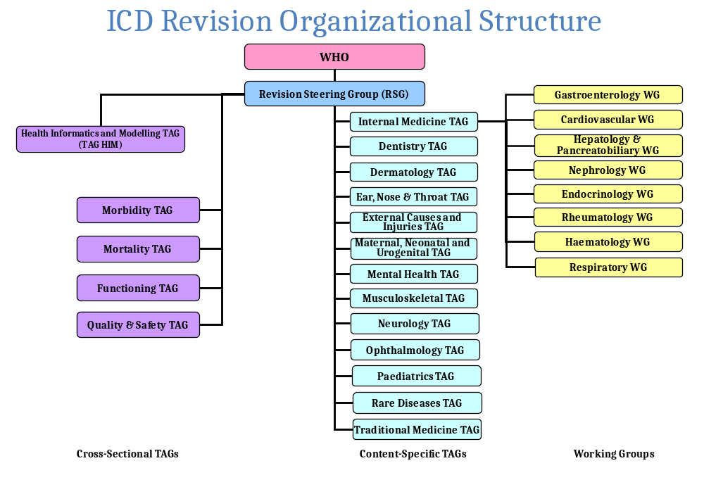
ICD-11 Revision plan chart
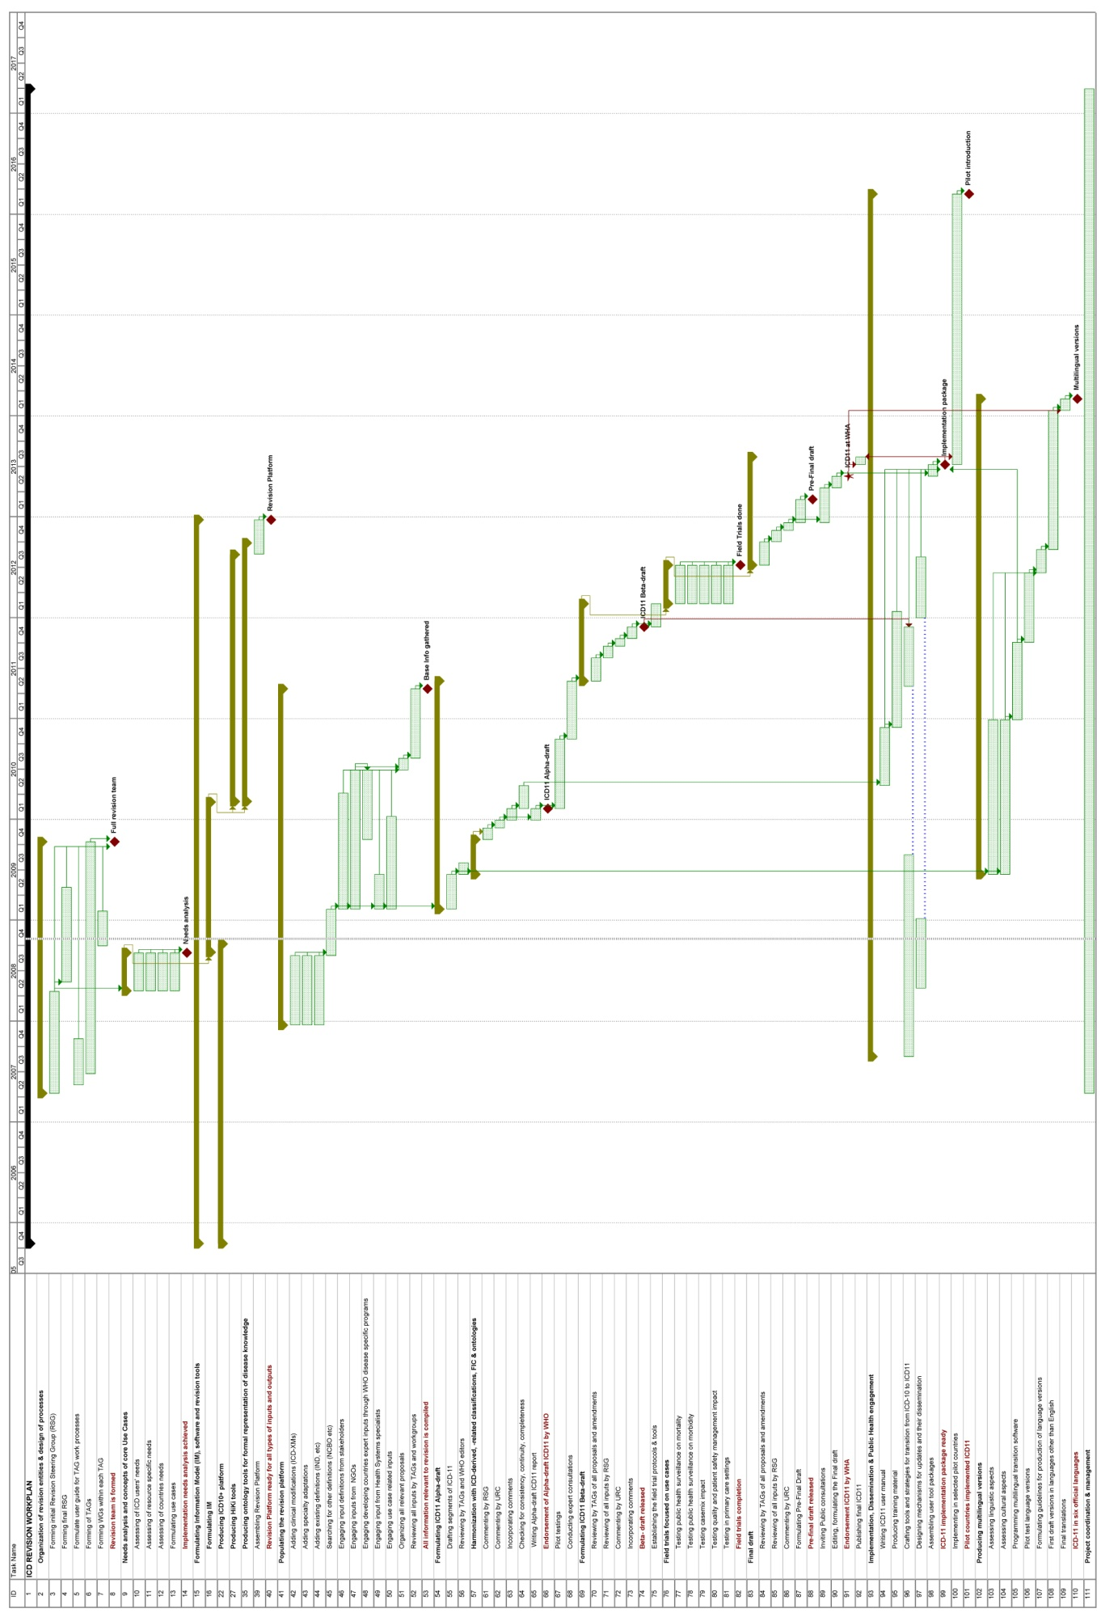

Version History
Date | Version | Modifications
12 February 2008 | 0.1 | Robert Jakob, Susan Fenton
21 February 2008 | 1.0 | Bedirhan Ustun
26 February 2008 | 1.01 | Robert Jakob
2 March 2008 | 1.03 | Bedirhan Ustun
3 March 2008 | 1.04 | Robert Jakob
5 March 2008 | 1.05 | Group work in DC
9 September 2008 | 1.09 | Robert Jakob
23 October 2008 | 1.10 | Robert Jakob
13 November2008 | 1.11 | Robert Jakob
17 December 2008 | 1.12 | Robert Jakob, Sara Cottler
10 February 2009 | 1.13 | Robert Jakob
20 February 2009 | 1.14 | Robert Jakob
17 April 2009 | 1.15 | Sara Cottler
15 May 2009 | 1.16 | Robert Jakob, Sara Cottler
21 July 2009 | 1.17 | Sara Cottler
11 January 2010 | 1.18 | Sara Cottler, Robert Jakob, Bedirhan Ustun
25 March 2010 | 2.0 | Sara Cottler, Robert Jakob, Bedirhan Ustun
Version 1 describes all aspects of ICD Revision project plan, in terms of processes, activities, products and various usecases. Version 2 includes solutions. The Revision Steering Group will decide together with WHO about the major version changes. Intermediate versions will document the progress of the document and will be assigned by the project management group consisting of WHO team and the chair of the RSG.

List of Acronyms
ATC/DDD | Anatomical Therapeutic Chemical Classification/Daily Drug Doses System
caBIG | cancer Biomedical Informatics Grid
CEN | European Committee for Standardization
CIOMS | Council for International Organizations of Medical Sciences
DSM | Diagnostic and Statistical Manual of Mental Disorders
FMA | Foundational Model of Anatomy ontology
G8 | Group of Eight leading industrialized nations
GIS | Geographical Information System
HIM | Health Informatics and Modelling
ICD | International Classification of Diseases
ICD-O | International Classification of Diseases for Oncology
ICECI | International Classification of External Causes of Injuries
ICF | International Classification of Functioning Disability and Health
ICPC | International Classification of Primary Care
IHTSDO | International Health Terminology Standards Development Organization
IND | International Nomenclature of Diseases
ISO | International Standards Organization
KMS | Knowledge Management System
MbRG | Morbidity Reference Group
MeSH | Medical Subject Headings
MRG | Mortality Reference Group
NLM | National Library of Medicine
OECD | Organization for Economic Co-operation and Development
OMIM | Online Mendelian Inheritance in Man
OWL | Web Ontology Language
RDF | Resource Description Framework
RSG | Revision Steering Group
SNOMED | Systematized Nomenclature of Medicine
SNOMED CT | Systematized Nomenclature of Medicine--Clinical Terms
SQL | Structured Query Language
TAG | Topic Advisory Group
UMLS | Unified Medical Language System
URC | Update and Revision Committee
WHO | World Health Organization

Glossary
Aggregation logic | Forming sets of elements that share one or more attributes, e.g. a category contains a group of diseases
Definition logic | Clustering of symptoms, signs and other attributes towards definition of a concept, e.g. diagnosis
Description logic | Defines relationship among elements and sets, here used in context of ontologies
Generic Usecase | Description and logical sequence of a set of usecases for a specific use of ICD
Linearization | Listing of elements of ICD according to a specified order that is shown as a tree that clusters elements of such list (alike any classification).
Purpose | Uses that ICD is designed for
Use | How ICD is used
Usecase | Single individual process where actors use ICD to achieve a specific output, and can rely on other usecases or be based on sub-usecases

Section I Goals and structures

Goals of the ICD Revision Process
The revision of the ICD will be guided by a set of goals, and use new technologies in a stepwise approach. The following paragraphs provide an overview:
- Establish ICD-11 as a user-friendly and scientifically credible classification that is continuously updated with the use of modern knowledge management and sharing methods.
- Provide evidence-based linking of each decision and category to the relevant scientific literature available as a dynamic classification system that will be regularly updated online through predefined processes overseen by expert advisory groups using a collaborative online platform.
- Link the classification to underpinning terminologies and ontologies (e.g. SNOMED-CT, GeneOntology and others) through human and machine readable formal descriptions (e.g. categories are defined by logical operational rules on their associations and details).
- ICD-11 linkage to terminologies and ontologies will be based on standard knowledge representation methods (description logic, aggregation logic, algorithms etc) to link the underpinning diagnostic constructs within a coherent information model.
- Ensure that ICD-11 will seamlessly function in an electronic health records environment.
- Serve as an international and multilingual reference standard for scientific comparability and communication purposes.

National Modifications
ICD is an international classification system; however, several countries may modify the ICD to meet their needs in practice. This limits comparability of data, development of guidelines, and linkage to knowledge bases and terminologies. WHO is working on ICD-10-XM, a cross-country version, which incorporates all of the national clinical modifications. The clinical modifications will be shown in the ICD-10-Plus structure. While ICD-11 cannot capture all of the varied needs of individual countries, substantial input to the revision process is anticipated regarding where the users need improvements to the ICD-10. In addition there may be a better structure for accommodating further national modification and their compilations (i.e. ICD XM as necessary, in the future).

Multilingual versions of ICD-11 drafts
It is a specific goal to make ICD multilingual in 6 WHO official languages with further guidelines and tools to make it available in other languages as it is an important international public good. Currently ICD-10 exists in 40 different languages and it is expected that the ICD-11 will also be available in as many as 40. Given previous experiences in multilingual production, WHO will use English as the master working version during the revision process with near-simultaneous production of 6 official languages. This means that master English version will be generated as a representation of language independent constructs and it will be represented with the best possible terms in other languages. Definitions, linkages to terminology systems and other knowledge bases could improve adequate linguistic representation in other languages. Multilingual representation will retain information about synonyms and preferred terms in one language, and about their linkages to other languages. The localized versions will be linked to the language independent representation of the concept.

Linkage to terminologies and ontologies
Classification means clustering information according to rules. The methods for grouping are driven by a specific purpose. Terminology contains information bits at higher granularity, (e.g. body parts, findings, or other elements that constitute a disease). In a terminology, a disease can be defined by establishing linkages between terminologies’ elements, such as anatomy or findings. Specific aggregation rules may allow grouping similar elements of a terminology (e.g. diseases) for specific purposes, thus creating a classification. It does not matter whether aggregates are incorporated in a terminology, or displayed separately as a classification. A classification system implicitly refers to terminologies and conversely a terminology system does the same. Terminologies and classifications should be considered as complementary and the implicit referencing should be made explicit. In the case of the revision, ICD represents the internationally agreed standard for aggregation and is developed in collaboration with the relevant stakeholders. SNOMED-CT is the largest clinical terminology compilation. Independent aggregation of disease concepts in ICD and SNOMED-CT leads to incompatible data and duplication of efforts. ICD and the leading terminology fit well together, being complementary elements of a health information system.

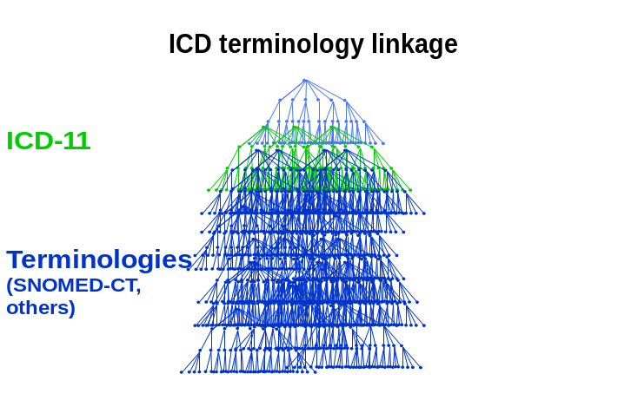
Figure 1 - Relation of ICD and SNOMED CT in terms of aggregation levels
Linkage to SNOMED-CT will apply to all definitions, inclusion terms (including relevant historical links, and index terms) and exclusion terms within the ICD, as much as the concepts bear the same meaning. Extent of definitions will evolve in stages following development ICD-11.
ICD-Terminology-linkage will require an ontological definition in a category of ICD that includes taxonomic status for one specific linearization, i.e. in what chapter, section in the classification tree the concept would be presented. Such taxonomic description includes information on whether the category represents a group of diseases, a single disease, disorder, injury, syndrome, sign, symptom, other ; its possible level of use in Primary care, Clinical Care, Research; and other characteristics such as periodicity, severity, chronicity, etc. The definition logic aggregates symptoms and findings to a new dimension: a disease concept of ICD, whereas the aggregation logic defines grouping of diseases in ICD.

Basic Taxonomic Principles and Health Information System
It is imperative to address the taxonomic requirements of a key classification as ICD to represent the health knowledge in appropriate fashion to be useful in health information systems. Data coded in ICD will be useful in public health decision making as an international standard specifically addressing issues of mortality and morbidity statistics, clinical decision making and other administrative decisions.
The WHO and the participants in the revision process should address, agree on and adhere to common taxonomic principles to maintain internal consistency and coherence of the ICD as well as its interoperability with other health information system elements. A classification should be clear about what it classifies: its universe, its key dimensions, its units of classification and definitions of these units, its organization in terms of its structure and relations among its units, and its presentations in different versions. Key taxonomic principles need to include epistemological clarifications, ontological definitions and pragmatic conventions as a result of common consensus. For example, as a classification of diseases ICD has to define what a disease is. So far ICD has not officially adopted a definition of disease. We have, therefore, compiled a working definition to guide the current work --which may be improved as the work progresses. The current working definition is as follows:
A disease is a set of dysfunction(s) in any of the body systems defined by:
1. symptomatology - manifestations: known pattern of signs, symptoms and related findings
2. etiology: an underlying explanatory mechanism
3. course and outcome: a distinct pattern of development over time
4. treatment response: a known pattern of response to interventions
5. linkage to genetic factors: e.g., genotypes, patterns of gene expression
6. linkage to interacting environmental factors

This definition is also intended to allow ontological analytic breakdown of each entity in ICD to define and identify whether it is a disease or other entity such as a disorder or syndrome, external cause and/or injury, sign or symptom, reason for encounter or unspecified. Such definitions will provide attributes which are necessary in creating an ontological system. ICD-11 will then be defined as an operational relational model of diseases and related health conditions which will have clear descriptions of each entity and their attributes such as body system, body parts, manifestation properties, causal properties, temporal properties (age of onset, age of occurrence and occurance frequency), severity properties, functional impact properties (limitations on cognition, mobility, etc. with their corresponding ICF code) and properties specific to certain heath conditions (pregnancy, gender, etc.).
This information will all be structured within an information model that consists of the dimensions that are used as split criteria ICD-10, already (current draft):
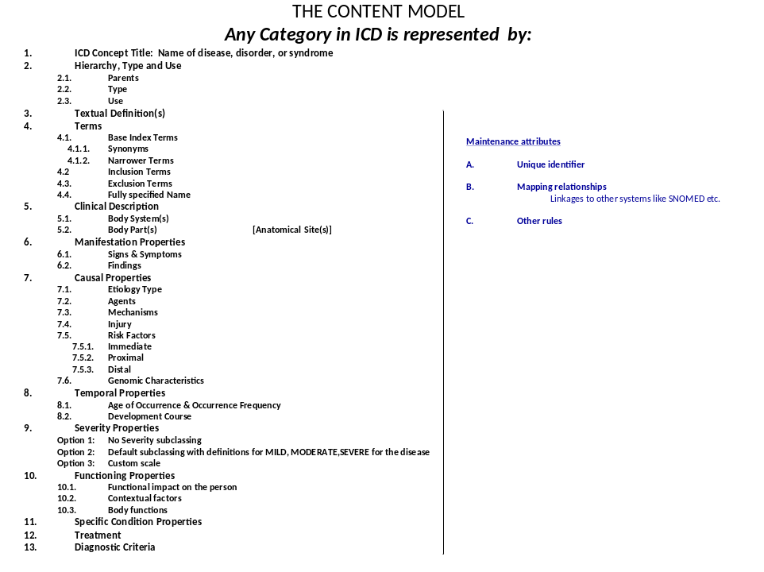
Figure 2 – Draft content model. Each entity in ICD will be defined with known ontological properties
Topic Advisory Groups will be given the mandate of formalizing core constructs and concepts of ICD-11 using the terminology/ontology iCAT tool to formalize the concepts and constructs using SNOMED and/or any other terminology. This formalization will be useful in creating knowledge linkages (also known as mappings) and algorithms for assessment tools or Clinical Interface (e.g. Map of Medicine).
However, relevant dimensions may differ among settings, as clinical medicine, pathology, or knowledge bases, as shown in disease models of SNOMED, or ICD-10 Classification of Mental and Behavioural Disorders. A special group (TAG HIM) will aim to define a disease model that accommodates the needs of the users of ICD, after assessment of existing models.

Usecases - Meeting the users needs
The ICD revision process aims to develop a coherent, internally consistent, and reliable international classification system that will serve multiple purposes:
  - Coding Mortality (causes of death)
  - Coding Morbidity (diseases and related health problems)
  - Specialty Adaptations and uses in different settings (e.g. primary care, clinical care) for different purposes (research, public health, quality, etc.)
  - Scientific consensus as high-level clinical phenotypes
  - Bearing consistency across these different uses so that data could be exchanged meaningfully

Backwards Compatibility
The ICD-11 follows software development practice in terminology, supporting a change history, and keeping compatibility with previous editions. While new diseases are certainly introduced as they emerge, outdated concepts of diseases, symptoms or syndromes will not be deleted, but inactivated and included in the index. Additionally, any changes in aggregation or other characteristics will be tracked to allow for longitudinal data use.

Web based distributed development
Former ICD revisions were conducted through week long revision conferences and multiple editorial groups communicating through conventional means (see introduction to Vol. 1 of ICD-10), and final editing by WHO. Given the opportunities presented to us by technological advancements, the ICD -11 drafting environment is planned as a Wiki–like structured Joint-Authoring Tool based on the collaborative web-based application that incorporates a structured information model and pre-selected standardized terminologies (see figure 1). This tool is called iCAT (initial ICD Collaborative Authoring Tool) and can be viewed at the following address:
http://icatdemo.stanford.edu
http://icat.stanford.edu

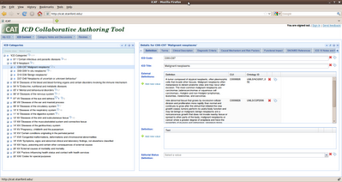

Figure 3- Screenshot of the iCAT Tool

Selected groups of experts will be given the mandate of drafting portions of ICD-11. Each Topic Advisory Group (TAG) will place their draft into the WHO web portal using a web based joint authoring tool. The ICD-11 draft will include information on parameters for each rubric wherever applicable such as the name of each category, relevant index and exclusion terms, as well as a structured description of the entity including clinical and/or research rules for diagnosis, descriptions of each body system, body parts, manifestation properties, causal properties, temporal properties (typical age of onset, duration for acute or chronic versions), severity properties, functional impact properties (activity and participation, as limitations on cognition, mobility, etc. with their corresponding ICF code) and properties specific to certain heath conditions (pregnancy, gender, etc.). Each rubric will be posted on iCAT, following a taxonomic review and clarification by WHO experts, as needed. WHO will also commission a structured scientific peer review to assure the quality of the submitted drafts such as completeness, adequacy, clinical utility, relevance for information systems and other aspects. This work is carried out by experts in specific disease domains in collaboration with user groups for ICD usecases.
Figure 4- ICD Revision Organizational Structure

The revision process will be open to many experts from all over the world. In order to facilitate better communication and collaboration the revision process will be open for comment to public. The Revision portal will be the single point of access for the update and revision process with different user interfaces, levels of access and editing rights.

ICD Revision Phases:
Towards an ICD-11, three major phases are planned:
1. ICD-10-Plus: This phase aims to compile all suggestions and user needs. A web-based platform called ICD-10-Plus brings together three main sources:
I. Combination of all additional codes from national modifications of ICD (e.g. USA, Canada, Australia, Germany, Thailand, Korea and others), primary care versions, and specialty adaptations (Oncology, Mental Health, Neurology, Headache, Sleep Disorders, Dentistry & Stomatology, Paediatrics and others).
II. Suggestions from different users and user groups: any interested person or group could make a structured proposal for a possible change in the ICD system.
III. Definitions of disease entities, as of IND, DSM, Orphanet, WHO, WHO Classification of Tumours, SNOMED...
2. ICD-11 alpha draft: will be compiled by the TAG Managing Editors and TAGs for review by the internal users (e.g. involved experts, core users as WHO FIC network,). It will contain reviewed conceptual structure and definitions at the level of detail that corresponds to blocks and three character categories of ICD-10.
3. ICD-11 beta draft: will be the field trial version for testing for its feasibility, reliability, utility and other predefined objectives. It will be simultaneously presented in 6 WHO official languages and tools for translations to other languages will be provided. The beta draft will be structured (linearization) similarly to the ICD-10 fourth edition with possible field test options to test the conversion from 10th to 11th version. This convergence will allow users to switch from ICD-10 to ICD-11 in a seamless fashion, and preserve statistical continuity.

Structure of ICD-11
The ICD-11 will be a set of dynamic relationships that are constantly updated.
The prevalent distributed version of ICD-11, a linearized view of the core structure, will continue to be based on the structure of ICD-10 and its alpha-numeric coding. The core structure of ICD-11 will fully reflect concept relationships and logical definitions, as a dynamic representation of scientific progress and will be continuously updated. Predicable, stable disease categories will be derived from this logic core, and be manifested as the ICD-10 style linearization.
More importantly, ICD-11 will be linked to ontologies and terminologies with human readable textual definitions, which are also in a computer format, thus allowing automated reasoning, decision support and user specific linearizations.
The information model will apply to all of the categories of ICD-11. Human and computer readable definitions for every rubric of the information model (where applicable) will be provided through linkages to established terminologies and ontologies. Structured full text definitions enable human editing and usage, and enforce consistency in use and translation. (Inclusion terms of the current ICD are at a higher level of detail and will not have their own definitions, unless evidence calls for separating some into individual categories in some linearizations, or they are language independent concepts relevant to accessing the relevant categories.)
ICD revision starts from present ICD structure first. This sets a clear starting point to offset the risk of biasing the revision.
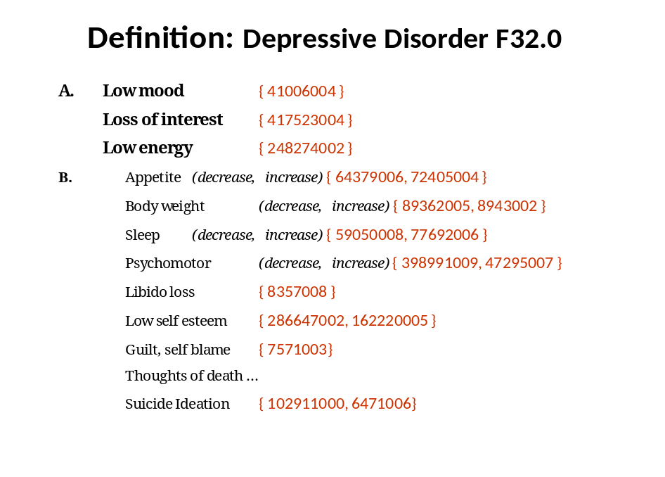
Figure 5 – Linkages between diagnostic criteria of ICD-10 category F32.0 and SNOMED
The joint proposed work with IHTSDO for the harmonization of disease classification terms will enable the building of these formalisms with standard tools. The knowledge representation underlying the constellation of clinical and laboratory findings related to the diagnostic categories in the ICD will enable better operational definitions in line with the information model. This can be described as aggregation logic or algorithmic approach.
It is essential that the ICD diagnosis can be further elaborated using clinical terminologies to formalize the diagnosis with operational algorithmic definitions. For example, F32 Depressive Disorder will be captured as SNOMED CT terms each coded and defined such as (Low mood, loss of interest, low energy, sleep problems ( insomnia, early awakening,…) appetite problems ( low appetite, binging…) sexual problems ( libido loss); guilt ; thoughts of death and suicidal ideation or acts. In the context of ICD revision DSM and ICD will aim at aligning their mutual definitions.
Similarly Tuberculosis, A15.0, will be further detailed by primary infection, positive tuberculin test, infection site (lungs, bone, kidney etc…) symptoms (coughs, sputum, fever, sweating, weight loss…) and findings (bacillus positive, culture positive etc).
This same process will be done for all areas of medicine under the WHO classification guidelines together with international experts in the related fields. WHO's previous work on specialty adaptations (such as classification of tumours and ICD-O, mental health etc) and joint work with CIOMS on International Nomenclature of Diseases (IND) will enable us to populate this model as it is fit for the template. Other work already existing in knowledge bases in rare diseases (i.e. Orphanet) and others will be incorporated in a similar fashion.

Section II- The Management Plan
The management plan provides an overview of the budget, describes tasks and progress, and analyses potential risks of the project.
This section describes the individual tasks in sequence, and includes their milestones. Tasks are divided into subtasks. The progress of tasks is detailed below. All tasks include descriptions of who will carry out the work. Potential risks are identified where necessary. Tasks contain cross references to relevant precursor tasks. For further detail, a Gantt chart can be made available. Milestones are highlighted with grey background and contain criteria for achievement, as necessary. Summary costs for achievement of the milestones are listed in a separate section, as is a summary assessment of risks.

Organization & Design of Revision Process
Goals and generic process of the revision of ICD are specified. A project team is formed. Tasks and workflows are formulated. Communication mechanisms between the teams are specified. Progress is tracked and reported.
Revision entities share work for specific parts of the revision work. A Revision steering group oversees and coordinates the overall work. Topic advisory groups (TAG) coordinate work for specific domains of ICD. One or more Workgroup review, summarize and work out change proposals for such domains. In addition, everybody contributes with suggestions and comments on the web based revision platform.
Coordination of workflows and roles in the revision process is specified in the Workflow document. Detailed workflows exist for the WHO Update and Revision platform. Workflows for the iCAT (Initial ICD Collaborative Authoring Tool) are currently being designed, and will depend on the progress of revision, stage of availability of iCAT, and tooling suggestions by the Health Informatics and Modelling Group.
Workflows are elaborated by WHO CTS team, in collaboration with the RSG and the TAG HIM. Resources exist.

Forming Revision Steering Group (RSG)
The Revision Steering Group (RSG) acts as an organism that assists WHO in the oversight and coordination of the revision process. Membership includes traditional stakeholders, and chairs of the TAGs. Membership should not exceed 12 persons to prevent inefficiencies in the work process. For the traditional stakeholders, coordination with the WHO-FIC Network is ensured by membership of one chair of the Network’s council. Specific guidance on past and present ICD maintenance needs in mortality and morbidity uses of ICD is provided by the chair of the WHO-FIC Update and Revision Committee (URC). Input on developments, and alignment of the other classifications members of the WHO FIC is carried out by the chair of the WHO-FIC Family Development Committee (FDC). A liaison between WHO-FIC and development of Primary care classification ICPC by WICC/WONCA) ensures close collaboration in this sensitive topic.
Resources ensure regular face-to-face meetings of the RSG.
Expansion of membership of the RSG is carried out by TAG chairs while TAGs are formed. An initial RSG is already operational.

Formulating user guide for Topic Advisory Group (TAG) work processes
The user guide describes the tasks (ToR), procedures, informs about criteria for selection of members, and contains also the necessary legal framework, as on conflict of interest, and intellectual property. A separate document exists and can be requested.
Edits by WHO are ongoing, in collaboration with chairs of existing TAGs, and the RSG. Edits concern mainly further specification of workflows and deliverables.
Resources for the production are ensured.

Forming of TAGs
TAGs organize the work for the revision of ICD in a specified domain based on procedural, terminological and taxonomical guidelines of the revision process. Equitable geographic distribution, expertise, and active leadership are guiding principles for membership. Further details about membership and tasks are specified in the manual for TAG and Workgroups.
WHO in collaboration with RSG, NGOs, and the WHO-FIC Network advocate for participation in the revision of the ICD. Press releases, internet sites, presentations at world summits of relevant disciplines, and information from NGOs will allow the mobilization of contributions in human and financial resources. TAG chairs are selected by WHO with advice from NGOs and the RSG. TAG chairs identify relevant experts following the rules of the manual. TAG chairs will seek WHO’s agreement for the membership.
Resources come from the TAG’s members donating their time and donors supporting the work. WHO will acknowledge TAG members with a formal letter, after signature of Declaration of conflict of interest and Intellectual property agreements.
Formation of TAGs is critical in adhering to the ICD-11 timeline up to the point of completion of the revision. Main input to the revision should come before the formulation of the Alpha draft. Some TAGs will provide input later. Structural changes, as well as creating new and changing cluster categories, can be taken into account until formulation of the Beta version in 2011. Minor edits and changes to individual categories at the terminology level, are possible until the end of the field tests (mid 2012).

Forming Work Groups within each TAG
Workgroups carry out the reviewing process by searching for evidence and incorporating comments and proposals in their specified domain. Formation of Workgroups is at the discretion of the relevant TAG. Members are appointed in agreement with WHO. Members and other contributors are acknowledged by WHO with a formal letter as Contributing Experts after signature of Declaration of conflict of interest and Intellectual property agreements.

Revision team is formed.
This milestone is achieved as soon as TAGs have been formed covering all domains currently contained in ICD-10. Where gaps in coverage persist at the time of formulation of the beta version, revision is informed only by existing clinical modifications, and proposals. Summary proposals in such case will be elaborated by MRG/MbRG.
- Needs analysis and concepts of core Usecases

Information on use and obstacles to implementation of ICD are compiled in an implementation database. Public health informatics needs are assessed in an online survey. Workgroups specify the usecases for ICD. A summary report is produced.
WHO has implemented the implementation database. Content comes from member states and from previous surveys.
WHO is conducting the Public Health informatics survey in collaboration with Michigan University.
Additional information on relevance of particular categories comes from crude frequencies of codes in mortality and morbidity databases.
Usecases are formulated by working groups (see 7).

Assessing of resource specific needs
This task is covered by user and country needs assessment and is not described separately.

Assessing of countries needs
Implementation Database and analysis of shortlists of diagnoses inform this task.
Work is carried out by WHO in collaboration with ICD experts from Collaborating Centres.
Resources are ensured by WHO and its Collaborating Centres.
Needs analysis achieved.

Formulating usecases
Public health surveillance corresponds to the most widespread use of ICD-10. Two variants do exist: mortality and morbidity data. Explicit definition of categories of ICD, incorporation of implicit coding rules of the index and of current Volume 1 of ICD, and incorporation of selection rules of volume 2 in descriptive logic will ease and standardize the use of ICD.
Additional uses that are relevant to the revision are casemix, quality and patient safety, and primary care settings.
A scheme for description of usecases has been developed. It is based on an IT modelling technique. A prototype of a mortality usecase description guides groups that work on other usecases.
The relevant usecases are identified with the aid of the WHO-FIC Network, and research groups. Specification of the usecases is ongoing.
The same groups will review or guide review of ICD-11 against these usecases.
Resources are assured for definitions. Resources for testing have to be identified.

Producing ICD-10 Revision Platform, Information Model (IM), Software and Revision Tools
The elements of the revision platform are designed and programmed in collaboration between WHO, Stanford University and The Mayo Clinic, under guidance by the TAG HIM.

Producing ICD-Revision Platform
The ICD-revision platform serves to collect all proposed changes and existing modifications to ICD in a startup linearization of ICD-11. Its content informs the work of the TAGs. The TAGs will discuss and post their summary proposals onto the platform. Workflows follow the one of the current updating process. Additional workflow elements apply to definitions and changes.
Resourcing is ensured for initial Collaboring Authoring Tool (iCAT) (see 3.3). The need for resources for the HiKi public commenting platform component will depend on progress and recommendations by the TAG HIM, and additional research outcome from the US NCBO.

Producing platform tool with ICD-10+ information
Production involves adding workflow for revision, and incorporating the information model template to the existing update platform.
WHO carries out the necessary work. Resources are ensured.
Production of the platform is critical to the revision. The work was achieved in 2008. Implementation of features for definition of categories depends on decisions and availability of value sets.

Identifying access paths for different users
Users of the revision platform are heterogeneous. Options for collaboration are dependent on the user’s role in the revision, and the type of contribution.
Main access paths have been identified by RSG and WHO. Additional ones may result from the work of the TAG HIM.
Work is achieved. Additional steps may be necessary pending input by the TAG HIM. Particularly levels of access pending role of the contributor still have to be implemented

Identifying workflows
Workflows of the platform will allow routing proposals for editing and discussion between different groups and layers of the platform resulting in different degrees of access to the proposal.
Proposals are routed by a moderator, or editing rights depend on layer and role. Comments are possible everywhere to everybody or comments are possible depending on role and layer.
Layers are switched by the group editor or by overall platform moderators on request by the owner of a proposal.
Swimlane diagrams identify the pathways for the Alpha phase, and separater ones expand these for input from a broader audience.

Programming commenting feature
Comments will be possible by proposal, by category, and by attribute of a category. Relevant functionality has to be programmed. Additional features allow identification of level of trust of a contributor.
Work is carried out by WHO.
Work for commenting proposals is achieved. Functionality for commenting attributes exists. It will come into practice pending progress of the tooling environment.

Formulating the Content and Information Model

Content Model
The "Content Model" identifies the basic properties needed to define any ICD concept (unit, entity or category) through the use of multiple parameters relating to its definition, and meta-information, category use, structural context in the classification, and versioning information, including time relationships.
The content model and these parameters are identified to systematically define a concept with its various attributes. To capture these attributes, the possible value sets are identified for each parameter to populate this database in a relational way. Each parameter need not be filled for each concept/category/entity.
The content model allows explicit machine-readable definitions of categories, linkages to standardized terminologies and ontologies, and the application of reasoning software used in the revision and maintenance of the classifications.
The content model is critical to the revision of ICD. It should be stable for the launch of the alpha draft in mid 2009. Failure will result in the need for large scale editing at a later stage, living with a dysfunctional model, and delays in definitions of the categories.

Information Model
Full formal population of this content model for each concept will result in an "Information Model".
Resources are ensured by current funds and donations in time by RSG, and TAG HIM members.

Drafting information model templates
Drafting of model templates starts from the implicit model that is the basis of ICD-10. WHO drafts first models on this basis. Criteria for use of descriptors of the information model have to be defined. Attributes of the information model have to be reviewed, and their use clarified.

Consulting with RSG and TAG HIM
Edits and usability of a prototype of the IM are assessed in collaboration with the RSG. Detailed design will be elaborated by the TAG HIM. Membership of the TAG HIM ensures that existing information models for diseases are taken into account.

Selecting value sets for each Content Model rubric
The task includes defining how a specific attribute should be applied to a particular disease, and defining and selecting the relevant value sets for each attribute of the Information Model.
Problems in defining the relevant value sets arise from:
- Non existing value sets for a specific attribute
- Intellectual property issues
For most of the attributes, the HIM TAG will consider short-term and long-term solutions to the modelling problems. Value sets for several attributes will come from SNOMED-CT. The agreement between IHTSDO will regulate any relevant Intellectual Property issues.
Resources are ensured by WHO and Stanford University. Additional resources may come from collaboration with NLM and IHTSDO. Most value sets are housed in NCBO’s BioPortal, a web application used to access the Open Biomedical Ontologies (OBO) library. This library contains a large collection of ontologies in biomedicine.

Content Model Style Guide for TAGs
TAGs will provide the definitions based on scientific evidence and international consensus. The WHO will provide guidance to the TAGs on how to fill in the content model, to make sure it is applied by all TAGs uniformly through both a written Content Model Style Guide document and a video tutorial of the iCAT tool. The Project Manager will be available to provide further assistance to TAG members where necessary.
The TAG-HIM will formulate the recommendations. Reviewing and piloting by sample TAGs will result in edits before the recommendations are shared with all TAGs.

Creating iCAT tool
Based on the content model structure and the relevant value sets, the iCAT tool will first become available for input and editing of definitions of ICD Alpha Draft Phase. Informed by the update platform and Mayo Clinic’s LexWiki and based on Web Protégé/Collaborative Protégé/BioPortal, the ICD collaborative authoring tool prototype is being designed. Multiple edits to linearizations (structural proposals) of ICD must be presented by the tool in a humanly understandable format. Frontends need to be shaped facilitating the input from the crowd.
Design includes features, technical approaches, frontends, and transition from or fusion with existing platform. Potential migration to, or incorporation of ontology tooling has to be planned.
The iCAT tool will allow edits of categories, linearizations textual definitions and clinical descriptions. Multiple edits may occur. TAG Managing Editors will oversee their will review the edits and decide about changes to the authoritative version of ICD. The iCAT tool will be used by selected classification experts as well as TAGs to evaluate the tool before becoming publicly available with the beta version. Earlier publication of alpha draft may facilitate improvements and completion of definitions.

Programming iCAT frontend
The frontend is the face of the tool. Simple, slightly different frontends will facilitate input by the crowd. The TAG HIM will help evaluate the progress of the tooling environment and give relevant recommendations. Managing Editors will give additional feedback based on their experience with the tool.

Programming terminology-ontology link feature
The feature allows viewing hierarchies of the relevant terminologies and ontologies while selecting the most appropriate concept for definition of an attribute of a concept of ICD.
Technologies for viewing and linking exist, e.g. at the NCBO Bioportal. Start of work depends on progress of the tooling environment and decisions regarding the Information Model. Implemented September 2009.

Programming revision specific workflow
Similar technical aspects apply for 3.1.3, Identifying workflows.
A simplified Alpha Drafting workflow is being implemented in the Alpha Draft tooling environment that will not include unaffiliated users and can be described as the following:
The overall ICD-11 Alpha Draft Workflow will start with the platform having a startup hierarchy with some categories having some prefilled information in some parameters and some categories without any.
Each category of the ICD will be assigned to one or more TAGs. These TAGs will be in charge for these portions. WHO will prepare this initial mapping but TAGs will be able to ask for additional categories.
During the process, both unpopulated and pre-populated categories can be edited by the TAG Editor(s) that are in charge for that category. After they populate the category’s content model they flag it to be discussed and approved by their TAG. The TAG may wish to make changes to the TAG Editor's content. Once the TAG has approved the category, the RSG may choose to send the category back to the TAG for further edits, or accept the content. This would lead to the WHO's role of approving or rejecting the category. If approved, the category would become a part of the Alpha Draft content.
Edits may be the result of recommendations by the TAG HIM and the RSG.

Programming commenting feature
For technical description see 3.1.4.
Feature is essentially implemented. Additional work will follow consolidation of the information model.

Programming structure editing feature
This feature allows making recommendations for structural changes of ICD in traditional linearization allowing the contributor to carry out the relevant change.

Programming linearization frontend
The linearization frontend will allow generating versions of ICD that differ in sets and arrangement of concepts.
Detailed specifications largely depend on type and linkages to other ontologies, on the developments in the ontology tool and on recommendations by the TAG HIM.
Resources have to be identified.

Producing ontology tools for formal representation of disease knowledge
The ontology tooling is the prerequisite for describing all relationships between ICD concepts and their attributes. Software (reasoners) can then identify logical conflicts with principles of classification, thus improving consistency and facilitating maintenance of ICD-11. Multiple conceptually consistent presentations (linearizations) that accommodate the uses of ICD in different settings can be produced that are based on structural definitions and external ontologies.
Work will be carried out by experts that need to be identified, in conjunction with Stanford/NCBO experts.
Funding is uncertain. Partial funding can come from a grant of the NIH.
This part of the project is relevant to accessibility of ICD in electronic environments and to facilitation of implementation. Non-achievement does not endanger the revision but will very much reduce functionality to the traditional level.

Programming RDF export/master import
This interface is relevant to communication with existing standards in terminology and classifications (options for maintenance and output, as LexGrid and ClaML are being discussed).
At an earlier stage of development, output for production of drafts would come directly from the iCAT. Achievement of this task is crucial to generation of customized versions of ICD, as soon as the whole ICD is described in OWL.

Assembling Revision Platform
ICD-10-PLUS was shaped for proposal based work. iCAT allows editing of the structure and content in a collaborative online format with formal standardized representation of ICD structure and content. The platform has a functionality that will be necessary for the revision, and the continuous maintenance of ICD.
Assembly means these tools communicate with the same database, or migration to one or another technical base preserves the functionality above.
Approaches to that task depend on development tooling environment. Feasibility of migration of ICD-10+ content needs to be assessed.
Funding has to be identified.
Effectors have to be identified.
Impact of failure depends on achievements in the tooling development. Guidance by TAG HIM can prevent technical obstacles. Failure while all tools are developed, will result in lacking functionality for output, or for input, and of the ICD-11 itself.
Revision Platform is ready for inputs.
The milestone is achieved, as soon as all components of the platform are ready. Achievement depends largely on funding, and on timely progress of the work of the TAG HIM. Partial achievements do not endanger the revision of ICD for traditional uses.

Priming the Platform: The Start-Up List
Existing edits to ICD, existing definitions and known problems with ICD will inform the revision and accelerate the revision process thus providing or proposing solutions.
Population with proposals depends on participation on the platform. Several points have been identified by present stakeholders already. Alpha Draft population will begin with TAG Managing Editors submitting their TAG’s proposals.
For progress in other subtasks, see below.
Limited funding is assured pending amount of work for routing and organizing proposals. TAGs are self-supporting.
Broad participation in this task is one core goal of the revision. Failure will result in parts of ICD that are not updated despite urgent need, in impaired acceptance of ICD-11, reduced evidence base, and reduced features that are related to the definitions, but will not endanger the uses of ICD-11.
Clinical modifications, reviews from TAG and input from stakeholders are necessary to the revision of ICD. Failure will make revision impossible. Input to the definitions is critical to features and linkage to ontologies and terminologies. Failure will result in lacking embedding of ICD in Health IT environment, and lacking consistency in data quality (status quo).

Adding clinical modifications (ICD-XM)
Countries have adapted ICD to better serve need in morbidity context. Usually more detail has been added.
Owners of such modifications have to be asked for permission to use information on type and site of such modifications to inform the revision. Permissions have to include presentation of the changed elements on the revision platform.
Modifications in languages other than English may require translation. Modifications may be present in different technical formats that need to be aligned for import on the platform.
Some modifications have been parsed and are on the revision platform. Copyright and confidentiality limit progress in importing others.
Conceptual additions have mainly been made in English, French, German, and Swedish. With respect to similarity of medical terminology there was seen no need for translations of these versions.
Resources come from WHO and Mayo.
The Start-Up Linearization for the Alpha Draft will include a digest of all available clinical modifications.

Adding specialty adaptations
Medical specialties have expanded ICD for more detail in parts relevant to them. Most adaptations date back 10 years, or more.
Access to the adaptations is limited, as electronic files are not accessible, or do not exist, except for the ICD for Oncology (current ICD-O-3), and the International Classification for External Causes of Injury (ICECI).
ICECI has been imported to the platform. Due to structure of ICD-O-3 such import will be of questionable advantage to the revision. For other specialty adaptations exploration for files is ongoing.
Present work has been achieved by Mayo and WHO.
Necessary additional resources depend on the source formats.
The Start-Up Linearization for the Alpha Draft will include a digest of all relevant and available specialty adaptations.

Adding existing definitions (IND, etc)
WHO and NGO own several sets of internationally agreed definitions. They are identified approaching systematically the relevant entities and solving potential copyright. Import of existing definitions requires conversion of formats from text into a format suitable to input to a database. Second step involves transformation into explicit machine readable definitions of the attributes of the Information model.
The International Nomenclature of Diseases was the terminological basis of ICD-10. It is co-owned by WHO and CIOMS. Majority of its definitions are available as electronic source files. Previous to import on the platform parsing and manual editing will be necessary. Work will amount to 10 person days.
At WHO’s, definitions of the manual for communicable diseases are accessible, TBC and Malaria programmes have definitions as well. Edits and parsing will be necessary. Some definitions are available from the Manual for reporting adverse drug reactions.
IARC owns definitions of Neoplasias (‘Blue Books’). Collaboration with WHO for the revision of ICD has been agreed.
Orphanet, platform for rare diseases and TAG Rare Diseases has well formed definitions of over 2000 rare diseases. 112 rare diseases have their own category in ICD.
Such work is resource intensive. For import of IND about 10 person days are necessary. Assumptions go for similar dimensions for the other sets of definitions, proportional to their size. Copyright has to be arranged with FIGO, and other NGO. Definitions of Orphanet were shaped for direct import. This part of the work has been achieved.
Necessary resources for format conversion and import are available at Mayo and WHO. Resources for transformation into machine readable definitions have to be identified. Part of it may come from TAGs’ work.

Searching for other definitions (NCBO etc)
Sets of machine readable definitions exist. They have to be identified, and prerequisites for inclusion in ICD have to be assessed. Among others, the NCBO is a typical portal that contains already a set of biomedical ontologies, with and without definitions.
The TAG HIM will identify other definitional systems, and assess quality and prerequisites to their inclusion.
Resources exist for assessment. Resources to a limited extent exist for inclusion in ICD, pending size of necessary legal arrangements, technical prerequisites.

Engaging input from all stakeholders
Categories with imported definitions and without definitions are presented on the iCAT online platform. Users of the platform edit the definitions and add missing ones. Users also make the explicit definitions of the attributes.
Prerequisites include availability of iCAT functionality, availability of the Information Model, and availability of TAG that verify, edit and agree on definitions.
Resources for iCAT exist at WHO and Stanford. Pending recommendations by the TAG HIM additional resources may be necessary. TAGs are starting their work in several fields. Specific editorial staff that work on the definitions has to be identified and funded.

Engaging inputs from NGOs
Broad input on the web based platform is one improvement of this revision of ICD. WHO advocates for NGO participation through media, attendance and organization of meetings.
Resources exist for individual trips. They have to be identified for organization of meetings.

Encouraging developing countries expert inputs through WHO disease specific programs
WHO’s disease programmes communicate with a large number of experts in the field in all regions. Such expertise is an asset to the revision, because it makes sure categories and definitions meet the needs in the field. Disease programmes ideally have one or more staff that coordinates input by these experts to the revision. Programmes include ICD work in their work programmes.
Resources for organization come from WHO. Resources for working time or travel of the abovementioned experts have to be identified.

Engaging input from Health Systems specialists
ICD is the basis for management of several health systems. Input consists of suggestion of categories’ suitability to health system information.
Relevant experts are available at WHO Department for Health systems. Other groups have to be identified.
Resources have to be identified.

Encouraging usecase related inputs
Usecases guide the development of ICD. Groups specify the usecases and verify existing and new categories for their suitability to the relevant use. Groups that carry out these activities are formed from relevant stakeholders. Advocacy and identification of stakeholders establishes contacts to such experts.
A set of usecases for purposes and relevant uses of ICD have been specified (work ongoing). Relevant groups are existing reference groups for mortality, morbidity, case mix experts, and initiatives and institutions for Quality Management and Patient Safety. For Primary Care, relevant contact is WONCA, and collaboration has been agreed.
Resources exist inform of voluntary contribution to Mortality and Morbidity. Limited resources exist for Quality and Primary Care.

Organizing all relevant proposals
Proposals for changes or non-changes to ICD are generated and put on the revision platform. TAGs have to synthesize summary proposals for their domains. This task consists of routing the proposals to the relevant TAGs, and rerouting according to issues of overlap between two TAG, as identified by RSG or TAG.
One full time assistant with knowledge of ICD per 400 proposals will be necessary to carry out that work. To a limited extent, with low traffic (up to 200 proposals) this work can be handled by the URC secretariat together with WHO.
This subtask is critical to the revision. Failure will result in incapacity to carry out the revision.
Resources are made available by WHO.
The Start-Up Linearization for the Alpha Draft will include a digest of all relevant proposals from the ICD-10 Plus Platform.

Reviewing all inputs by TAGs and Workgroups
TAGs receive all proposals that relate to their domain. They receive summary proposals from their different workgroups. They review the relevant proposals and create summaries following their work instructions or the relevant domain. Work includes organization of teleconferences, routing email and organizing and attendance of face-to-face meetings.
Resources are needed for 3 meetings for a TAG (kick-off, alpha draft, beta draft, teleconferences, at least 1 face to face meeting of every single workgroup). Linking such meetings to international meetings of relevant NGOs, or scientific societies reduces necessary budget. Working time is donated by the members of TAG and Workgroup, in addition to financial and organizational support by NGOs and member states. Compensation from WHO consists of acknowledging their contribution in an official letter and naming the contributor in the context of the work.
Work is assured for Dermatology, External causes and injuries, Internal Medicine, Maternal and Perinatal Health, Neoplasms, Neurology, Ophthalmology, Psychiatry, and Rare Diseases. Under exploration are Dentistry, Orthopaedics, and reasons for encounter. Groups for infectious diseases and urogenital diseases have to be identified by WHO.
The task is critical to the evidence base and up to date definitions. Failure will result in very limited review of ICD, and uncertain bias of revised parts of ICD-11 by interest groups (advocacy, political, or scientific).
All information relevant to revision is compiled.
The milestone is achieved as soon as all tasks under 4 “Priming the Platform” are achieved.Priming the Platform: The Start-Up List’ are achieved.

Formulating ICD-11 Alpha-draft

Alpha Drafting Workflow

The diagram below illustrates the ICD-11 Development workflow. It is a UML activity diagram which is divided into swim lanes in order to illustrate which actors perform which tasks. The diagram is mainly focused on jointly editing the classification and covers both alpha and beta drafting stages. The components which are colored as blue are specific to the beta drafting and the rest are common to both stages.

What is not included

The following aspects have not been covered in this diagram and there will probably be separate workflows diagrams for them. ICD Content to TAG matching.

Recruiting reviewers

Engaging public into the process. Detailed feedback mechanism for their contribution.

Translating the classification.

How to read the diagram

Black points:

These are starting points for the workflow.

Rounded rectangles:

These are activities performed by the actors

Arrows:

Arrows show the control flow. E.g. an arrow between rectangle A and rectangle B means the activity in the rectangle A has to finish before the activity in rectangle B starts.

Diamonds:

If there is one input and multiple outputs, this means a decision is taken based on the activity that has performed.

If there are multiple inputs then it means a merge. I.e. any of the inputs to the diamond is sufficient for the workflow to continue with the next activity

Roles

Public:

Community that is contributing to the ICD development by making change proposals to the classification.
- Community Engagement Group:
The group between the public contributors and the TAGs that will be filtering the public input and if necessary sending feed back to the public.
- Reviewers:
These are the external reviews who will review the ICD categories. The unit of these will be one ICD category andit will cover all parameters of the category.
- Classification Experts (Mortality and Morbidity TAGs)
Classification experts will be reviewing the classification from the traditional use case perspectives (mortality and morbidity coding, statistical continuity).
- TAG & TAG Workgroups:
All members of the TAG and its workgroups

TAG Managing Editors:

TAG Chair:

RSG:

WHO:

Detailed Descriptions
The numbering below is in line with the numbers in the diagram.
1: Alpha drafting workflow starts with the TAG chair and TAG managing editor giving directions to the TAG members on populating the content model as well as restructuring the relevant portion of the classification. ….
2: Updates (content & structure): This is the part where the actual content editing and changing the structure and linearization occurs. Even though it is not visible in the diagram explicitly, any task in this area can be performed by the TAG managing editor (TAGME) as well since he/she is also a TAG member. Structural changes can be done only by the TAGME in order to have them done in a consistent manner.
3: Reviews We have two types of reviews in this process:
- Content reviews where external reviewers will review the category including the textual definition and populated model parameters. The unit for this review type is one category
- Structure and linearization reviews will be focused on the classification from the traditional use case perspectives (mortality and morbidity coding, statistical continuity). Classification experts will be reviewing the parent/child relationships as well as the linearizations. The unit of these reviews is a sub-tree (i.e. block) in the classification.
4: TAG Managing editor updates the classification according to the reviews.
5: TAG members, TAG Workgroup members and Classification experts provide comments on the changes occurred in 4.
6: TAG Chair makes a decision taking into account TAG input and the original reviews. He/she may approve the changes or may send it back to the TAGME with his feedback.
7: If there is another TAG involved in this portion of the classification then agreement needs to be sought between the TAGs. If they agree the updated content can be sent to RSG for their review. Otherwise it’s again sent to RSG but this time for conflict resolution.
8: RSG reviews the new content and if they approve it is sent to WHO for review. Otherwise if the content is not approved, then the TAG will be informed about the decision together with the feedback from RSG.
9: Public Proposals: In the beta phase, we will allow proposals from everybody who would like to contribute in the development of ICD-11.
10: Public proposals will be filtered by the “Community Engagement Group”
11: The public proposals can be commented by the TAG members and TAG workgroup members
12: Taking into account the TAG feedback in the previous step, TAGME will process the public proposals at certain intervals. He/She will aggregate proposals that relate to the same category and update the classification accordingly. Once the updates are done the workflow is similar the same as described above (Step 2 and onwards)
Note:Depending on the number of public proposals to be processed, we may need to have this step performed by people other than the TAGMEs.

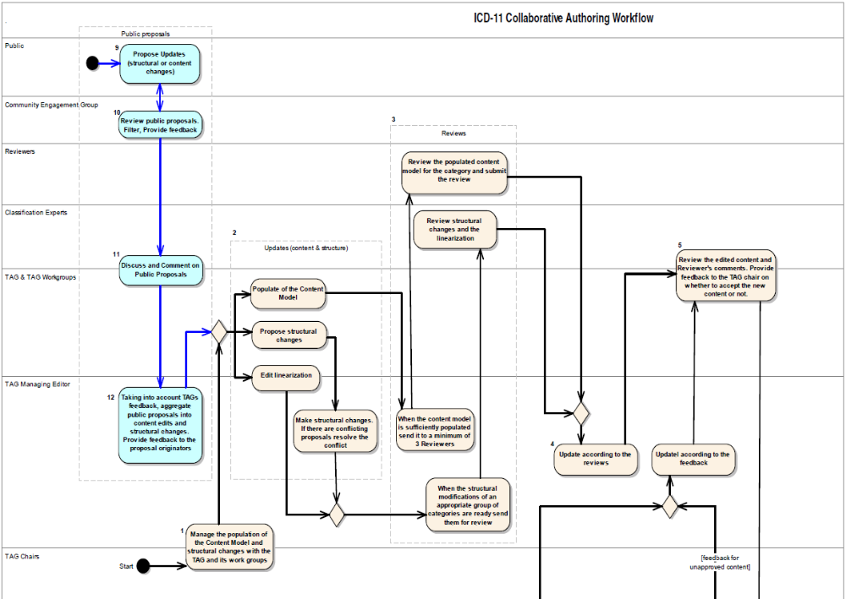
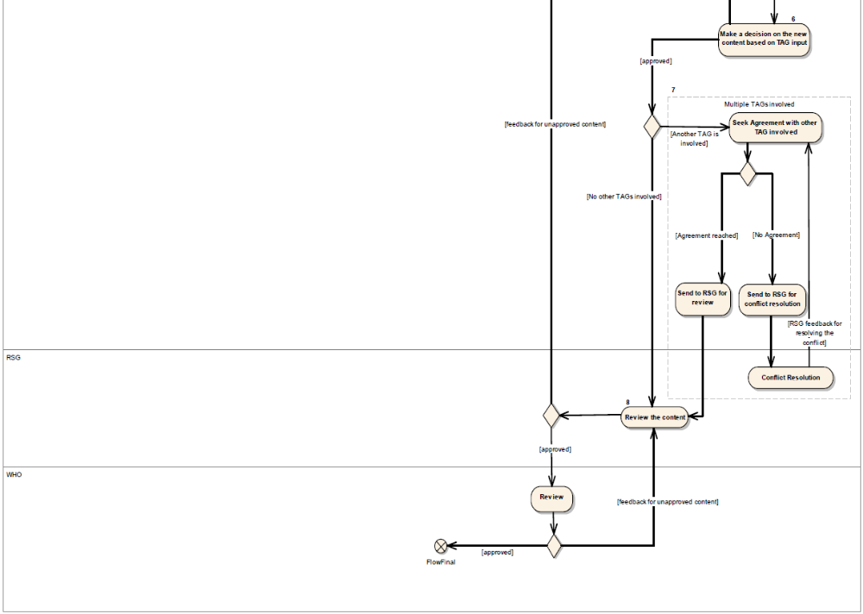
Figure 6 Alpha Draft Workflow

ICD Category Assignment to TAGs
The overall ICD-11 Alpha Draft Workflow will start with the platform’s initial startup hierarchy with some categories having some pre-filled information in some parameters and some categories without any.
Each category of the ICD will be assigned to one or more TAGs. Knowing which TAGs are working on which ICD categories is important in our workflow because only the relevant TAGs will have necessary rights to edit the content of a particular category or changing the status of content. WHO will prepare this initial mapping but TAGs will be able to ask for additional categories. The initial mapping will be provided by WHO. TAGs will send their feedback on this initial list by asking for additional categories as well as removal of categories. The updates of this mapping will be organized by RSG.

Populating the Content Model
During the process, both unpopulated and pre-populated categories can be edited by the TAG Editor(s) that are in charge of the category. After they populate the category’s content model they flag it to be discussed and approved by their TAG. The TAG may wish to make changes to the TAG Editor's content. Once the TAG has approved the category, the RSG may choose to send the category back to the TAG for further edits, or accept the content. This would lead to the WHO's role of approving or rejecting the category. If approved, the category would become a part of the Alpha Draft content.
Populating the content model is managed by TAG Managing Editors (TAGME). They may involve other TAG members or TAG workgroup members in this process. If there are multiple TAGs involved in the revision on an entity, the TAGMEs are encouraged to communicate with the other related TAGMEs as early as possible in order to avoid conflicting edits. The software platform will provide information on which TAGs are assigned to which categories.
Resources come from TAGs, collaborating centres, and WHO. Resources are being identified.
Populating the Content Model is a critical task for the revision. Failure results in failure of delivery of ICD-11.

Peer Review Process
When TAGs are satisfied with the content, they will send it to a minimum of 3 reviewers. The unit of review will be one ICD category. However, groups of content can be sent to the reviewers together.
After the reviews have been carried out, TAG managing editors will update the content taking into account the reviewer’s input and consequently mark the content as ready for TAG review.
The iCAT tool will include a tool for reviewers that is integrated into the platform, similar to BenchPress to assist the automation of the review workflow.
If the TAG is happy with the content they forward it to RSG. If not, they may be able to send it back to TAG Managing Editor for further edits.

Structural Changes
Structural changes to the classification (i.e. changing parent/child relations) can only be done by the TAG managing editor and classification experts. In either case, it is reviewed by the classification experts in a way similar to the review mechanism explained above. The unit of the review for the structural changes is a sub-tree (i.e. block) rather than a category. This review takes into account the changes in the structure as well as changes in the linearizations.
If other TAG members or TAG workgroup members would like to change the structure, they should prepare a proposal which will be taken into account by the TAG managing editor.
Editing the linearization means deciding which ICD category is included in which linearization and in the case of multiple inheritance, deciding which parent will be used in the linearization.
Similar to the structural changes, editing the linearizations can only be done by the TAG managing editor and classification experts.

Areas of Overlap & Areas of Conflict
In the case for an ICD category that is owned by multiple TAGs, the primary TAG is in charge of routing the content. However, they need to seek approval of all of the TAGs involved before they forward the content to RSG. If multiple TAGs cannot agree on a particular issue, they may raise a conflict flag together with relevant documentation which will be examined by the RSG.
TAG chairs are responsible to enter TAGs decisions on the platform but they may delegate this to another person.
If the content comes to RSG as a conflicting issue they discuss it with the related TAGs and submit their decision to the TAGs who will update the content accordingly.
If the content arrives RSG without a conflicting flag, RSG may approve the content and forward it to WHO or they may send it back to the TAG if they believe further updates are required. In this case they summarize the reason why they send it back to the TAG so that they can take action accordingly.

Reviewing by Classification Experts
A TAG Mortality and TAG Morbidity are being formed to evaluate revision proposals from a classification perspective.
The Terms of Reference are being developed and the TAG formation will follow.
Comments will be reported to WHO and the RSG, and where necessary, TAGs will make edits accordingly.
Resources come from the collaborating centres.

Commenting by RSG
Final summary proposals from TAG are reviewed by the RSG together with the TAG’s report on process and arguments. Persisting conflicts in issues of overlap between two TAG will be arbitrated by RSG, and in case of failure of arbitration decided in discussion between RSG and WHO.
Amount of work will be shared between the members of the RSG. No member reviews the work of its own TAG. Results of the reviews will be reported for discussion at the Alpha draft meeting of the RSG. No additional content experts are consulted.
Resources include donation of working time, one meeting and communication with TAG, as necessary. Financial Resources exist with WHO.

Harmonization with FIC & ontologies
The classifications of the WHO FIC overlaps in specific areas. The same applies to linked ontologies and terminologies. Pending specific shaping of concepts for specific uses, such shared conceptual domains should share the same concepts. Only some Members of the WHO-FIC are owned by WHO.
Work will consist of the set of tasks below.
Resources come from all involved parties. Travel costs are not ensured.

Solving copyrights and other legal issues
Copyright and legal issues are relevant where sources are outside WHO. Issues are solved by agreements with relevant entities. Such entities are WICC/WONCA for primary care, IHTSDO for clinical terminology, WHO collaborating centre for Drug Use (ATC/DDD) in Oslo, and the WHO collaborating centre for drug monitoring in Uppsala.
So far, an agreement with WICC/WONCA ensures ICPC-3 and ICD-11 will be developed ensuring matching concepts. This includes using the relevant sets of concepts on both sides.
An agreement with IHTSDO is close to conclusion; discussions with the drug centres are progressing.
Need for additional arrangements depend on the specifications of the Information Model.
WHO carries out the work.
Resources are ensured.

Consultation with other product owners
Consultation with other product owners relates to terms of collaboration ensuring development of aligned conceptual bases in the ICD and the ‘other’ system.
WHO carries out the consultations.
Resources are ensured.

Modifications and alignment
Editing external systems or concepts of ICD is aimed at establishing conceptual consistency. Working procedures need to be established that allow such alignment.
Steps include: identification of areas of overlap.
Endorsement of Alpha-draft ICD-11 by WHO.
WHO will consider endorsement of the alpha draft, after all concerns of RSG and the Classification TAGs have been duly taken into account. The alpha draft is a frozen state of development of the ICD-11 that will include a large part of the structural changes, and the majority of the definitions. The Alpha draft will be produced in a traditional print and electronic format. The Alpha Draft will also include a Volume 2 containing the traditional sections and including a section about the new features of ICD-11 in line with the style guide. An index for print will be available in format of sample pages. A fully searchable electronic index using some of the ontological features will demonstrate the power of the new ICD.

Incorporating comments

Checking for consistency, continuity, completeness
Consistent use of terminology and the information model is verified, and edits are made in collaboration with the relevant TAG. Backwards compatibility is assessed. Where continuity does not exist, facts are reconfirmed with TAG, as necessary. Existence of suitable categories for all cases is verified, through comparison with ICD-10.
Work is carried out by WHO editors. The amount of work depends on the amount of proposed changes. Dimensions will be an estimate of 1 person year of ICD expert.
Resources are in part ensured by WHO.

Writing Alpha-draft ICD-11 report

Pilot testing
Pilot testing will show feasibility and utility of selected parts of ICD-11. Selection criteria include number of changes per section (more than 20%), parts that caused conflicts in overlap between two domains, or in linguistic assessment.
Pilot testing will include double coding (ICD-10 and ICD-11), and parallel coding (inter rater reliability, inter language reliability). Cases have to be identified; hospitals and other facilities have to be contacted for double coding.
RSG will consult with WHO on the parts that are piloted. RSG, Collaborating Centres and TAG ensure availability of the relevant facilities. Evaluation is done by the RSG. Results are discussed with the TAG upon solicitation by the RSG.
Resources are uncertain and depend on the availability of facilities that have to be contacted.
Failure will result in reduced evidence for choices aiming at solution of problems that arise in the revision.

Conducting expert consultations
Alpha draft of ICD-11 is presented to experts on the revision internet platform. WHO departments, members of national or international institutions that are involved with one or more use of ICD, will be invited to give their feed back.
WHO and RSG identify relevant contacts. WHO invites for comment. Results are forwarded to TAGs by WHO editors.
Resources are ensured for initiating consultations, and commenting on the revision platform. Additional face to face meetings are not planned. For several experts this can be achieved in the context of relevant meetings at WHO’s. Timeline for revision is a constraint to this approach.
Failure will result in reduced evidence base and reduced acceptance of ICD-11.

Formulating ICD-11 Beta-draft
Beta draft is informed by expert reviews and pilot test of the alpha version. Beta draft is used for field testing.

Reviewing by TAGs of all proposals and amendments
TAGs receive comments and results of pilots of their domain. TAGs review evidence for proposed changes and edit their summary proposals. Some TAG that were formed late may still provide input to revision the same way as the early ones did for the Alpha draft.

Reviewing of all inputs by RSG
Amended summary proposals are reviewed by the RSG.
Work will be an estimate 20% of the review of the Alpha draft (pending amount of work resulting from late proposals), is 9 person weeks, to be shared among the members of the RSG, and one face to face meeting.
Resources are ensured by WHO.

Commenting by URC
Work will be an estimate 20% of the review of the alpha draft, is about 3 person weeks.
Resources come from the collaborating centres.

Incorporating comments
WHO and WHO editors review comments and edits, and arrange for edits to the alpha draft, as necessary.
Resources are ensured by WHO.
Beta - draft released
This work is achieved with the milestone publication of the beta draft of ICD-11. It is independent from production of manuals or print products that are prerequisites for field testing.

Establishing the field trial protocols & tools
Field trial protocols will identify suitability to usecases, inter rater reliability, feasibility, and IT integration. Trials and protocols will be informed by testing of ICF and by bridge coding protocols that were used in transition from ICD-9 to ICD-10. Existing protocols have to be reviewed, and rewritten for ICD, with additional sections that are specific to the usecases.

Field trials focused on usecases
A set of generic usecases reflects the needs for ICD-11 based on experiences with ICD-10. Usecases are formulated by current stakeholders. The stakeholders are organized in TAG like structures by usecase. These groups will start their work reviewing the structural changes proposed throughout the different drafting phases, and draft and coordinate field tests.
Agreement on disease concepts, phenotypes, is relevant to all usecases.
Clinical phenotype and public health phenotype are put under one hood, as most public health relevant diagnostic data are output from clinical context. Delineation to terminologies will depend on use.

Mortality
Field tests consist of double coding of existing electronic full text certificates of death will ease understanding of statistical impact of changes implemented in ICD-11, and indicate achievability of current categories. Data exist at the US NCHS, and with reduced level of detail at French INSERM. Other sources may follow by the time of presentation of the beta version due to efforts of introduction of electronic certificates of death. Limitations way result from confidentiality and related national legislation. Work is carried out by the national entities that handle the data. Several of the abovementioned are collaborating centres.
Additional field tests depend on the explicit description of the rule base in Ontology Web Language (OWL), and linkages to terminologies. They include automated derivation of cause of death from patient records and logic software that applies selection and coding rules.
Resources come from centres and relevant institutions. Funding for evaluation of the outcome has to be identified.
< Further detail under development>

Morbidity
Relevant group of the WHO-FIC Network specifies the usecase.
Effectors and resources for field testing have to be identified.
< Detail under development>

Casemix
Casemix systems that are based on ICD currently guide payment systems.
< Detail under development>

Quality and patient safety management
A working group specifies the generic usecase and the specific usecases. ICD is tested against such usecases.
Input comes from Global alliance for Patient safety, JCAHO, IMECCHI, and other institutions.
A group is currently forming and formulating its working materials.
< Detail under development>

Primary care scenarios for activity, quality, and financial administration
Primary care scenarios of the abovementioned generic usecases share importance in assuring health services, limited resources and direct involvement in prevention programmes. Appropriate simplification of ICD and representation of appropriate concepts in ICD has to be evaluated.
Input and work comes in collaboration with WICC/WONCA. Additional effectors have to be identified.
Resources have to be identified.
< Detail under development>
Field trials completion
The milestone is achieved as soon as all ICD-11 has been tested in all mentioned usecases, and reports are available. Failure will result in uncertain usefulness of ICD for untested usecases.

Final draft
Final draft incorporates outcomes of the field trials, last consultations between WHO, NGO and major other stakeholders. Preliminary comments from reviews by WHA may feed into the final draft as well.

Reviewing by TAGs of all proposals and amendments
TAGs receive comments and results of field tests of their domain. TAGs review evidence for proposed changes and edit their summary proposals. Input from late TAG work can be considered for definitions and isolated changes of categories that have no impact on other domains.
Resources come from TAGs.

Reviewing of all inputs by RSG
Amended summary proposals are reviewed by the RSG.
Work will be an estimate 20% of the review of the Beta draft (pending amount of work resulting from late proposals), is 2 person weeks, to be shared among the members of the RSG, and one face to face meeting.
Resources are ensured by WHO.

Commenting by URC
Work will be an estimate 20% of the review of the beta draft, is about 1 person week.
Resources come from the collaborating centres.

Formulating Pre-Final Draft
WHO and WHO editors review comments and edits, and arrange for edits to the beta draft, as necessary. WHO editors edit Instruction manual and verify index and synonyms.
Pre-final draft released
The prefinal draft is available for public viewing online. A print version of standard linearization (alike ICD-10) is produced.
Resources are ensured by WHO.

Inviting Public consultations
Press release and a WHO press conference announce availability of the prefinal draft of ICD-11 for public commenting. A circular letter by the Director General of WHO invites Member States for comments.
Resources are ensured by WHO.

Editing, formulating the Final draft
RSG and URC consult for necessary edits. Proposals for major structural changes are forwarded to the relevant TAG for comment. Pending feedback RSG and URC make final recommendations. TAG reports are put together into the revision report.
WHO editors carry out the changes, and produce the revision report.
Resources are ensured by WHO, URC members and TAG, pending amount of necessary work.
Endorsement of ICD-11 by WHA.
WHA receives Final draft 6 months preceding the general assembly of the WHA, together with the revision report, and adopts the ICD-11.

Publishing final ICD-11
Amendments that are requested by the WHO are carried out by the WHO editors. A classic print version of ICD is produced. Electronic versions for incorporation in software and lists for statistical reporting are produced.
Work is carried out by WHO editors with assistance by the revision platform, the TAG HIM, and the Electronic Tools Committee of the WHO-FIC Network.
Resources are ensured by WHO in part. Amount of software assistance depends on success in the development of the relevant parts of the revision platform, in particular the ontology tooling.
Progress in ontology tooling will impact on necessary minimum functionality of the other parts of the revision platform in order to enable production of the ICD-11 for the different media.

Implementation, Dissemination & Public Health engagement

Writing ICD-11 user manual
The user manual will instructs customers of correct use of ICD and ensures consistence use of ICD.
ICD categories are specified for use in specific contexts, as mortality and morbidity. Rules for selection of a single cause are specified. Instructions for coding that is based on paper versions and for electronic versions are formulated. Rules for access to and incorporation of specific database versions of ICD are formulated. Conventions of ICD are described. Rules for statistical presentation are formulated. International legal conventions for use of ICD in Member States are added.
Use of categories is specified by TAGs in collaboration with usecase groups as soon as the relevant parts of ICD-11 are compiled.
Coding rules for the relevant versions are taken from current ICD version and adapted by usecase groups.
Effectors for instructions that relate to database versions have to be identified. The TAG HIM is recommended for this work.
Summary editing is carried out by WHO.
Resources include donation of working time by TAG members, workgroup members, collaborating centres and WHO.
Majority resources are ensured. Additional resources for editorial assistance have to be identified.
Failure will result in failure of producing ICD-11.

Producing training material
Training material for ICD-11 refers to training on structure, content, maintenance and proper use of ICD. Training material comprises lessons on structure, content, and proper use of ICD on syntax, as well as standards for metadata in context of ICD, quality assurance, principles of classification and terminology, statistical presentation and confidentiality. Information on maintenance will increase awareness of mechanisms for participation in the continuous improvement and adjustment of the ICD.
Training material is currently compiled for ICD-10. Content follows the elements above that are founded on 15 and more years of training experience with ICD-10 and precursors (core curricula elaborated by the WHO-FIC Network). Present production allows easy adaption to ICD-11, and expansion for additional lessons, e.g. on relationship between different linearizations, scope of definitions, linkages, use in conjunction with linked terminologies and ontologies.
The majority of necessary changes and additional will become apparent with the Alpha version of ICD-11. The timeline allows having the training materials ready for the field tests.
Editors, authors, and financial resources for adaptation to ICD-11 have to be identified. Collaborating centres may act as editors or reviewers, pending funding.
Sustainable mechanisms and resources for updating in line with updates to ICD-11 have to be identified.
Failure results in delayed implementation and inconsistent use of ICD-11.

Crafting tools and strategies for transition from ICD-10 to ICD-11
This set of instruments includes transition tables, algorithms for assessment of statistical impact of transition, and procedural descriptions for implementation of transition.
Transition will be easier than the one from ICD-9 to ICD-10. ICD-11 is built starting from ICD-10. Electronic explicit tracking of conceptual changes will allow automated creation of transition tables for the major part of the classification. Human review is necessary for thoroughly changed parts of ICD. The electronic tracking of changes (e.g. of source concept in ICD-10 and target concept in ICD-11) allows also identification of areas of potential statistical continuity. Existing full text electronic death certificate data allows double coding of the same source data.
This task is critical to adoption of ICD-11. Failure results in delayed implementation or non implementation of ICD-11.
Resources have to be identified.

Designing mechanisms for updates and their dissemination
The iCAT allows continuous commenting and proposing of changes to ICD. This input is reviewed on an annual basis. Reviews inform amendments to ICD-11. Changes are published online for automated and manual incorporation in electronic systems. Files of updates for print are available online. Publication of updates is announced in the WHO Bulletin. Paper based versions are produced every 6 years.
The public makes proposals and provides some evidence. TAGs continue to exist after revision and review these comments as for the interim versions of ICD-11 (Alpha version and Beta version). WHO disseminates the updates.
RSG and Mortality and Morbidity Advisory Groups review proposed edits. TAG Managing Editors carry out the edits.
Sustainable resources have to be identified.
Failure results in irregular or missing updates and/or their dissemination. In consequence compilation of international statistics is limited by incompatibilities between different versions of ICD-11.

Assembling user tool package
The user tool package includes training tools, sample implementation strategies, and translation tool.
WHO editors pull together the tools on a single CD or other portable format.
Resources have to be identified. Collaborating centres can assist WHO in this task.
Failure results maybe in delayed implementation.
ICD-11 implementation package ready.
All tools under 7.4-7.8 are available. Assembly (7.9) is an asset.

Implementing in selected pilot countries (developed and developing)
Implementation in pilot countries will allow assessment of routine data collection and technical incorporation of ICD in countries’ health information systems.
Selected translations are made by collaborating centres of Alpha, Beta and Final Version of ICD-11.
Selected countries implement full ICD in selected coherent parts of their health information system, as in one administrative region for all applicable usecases.
Volunteers are invited by WHO.
Resources come from some countries. For low resourced countries, sustainable funding has to be identified. Pilots can be part of a donor project for implementation of a specific component of health information, as mortality.
Failure will result in lacking information for implementation obstacles at level of concepts, produced formats, language and cultural aspects.
Pilot countries implemented ICD-11.
Selected countries have implemented full ICD in selected coherent parts of their health information system, as in one administrative region for all applicable usecases.

Producing multilingual versions

Assessing linguistic aspects
Languages have different sets of preferred terms and synonyms that may or may not correspond to the ones expressed in the English master version. Conceptualization of diseases may differ depending on language and culture.
Linguistic assessment comprises:
- Summary of translation problems with previous versions of ICD, and other classifications
- Reporting translation problems in early language versions at Alpha stage
- Translation and back translation of core concepts and category titles on a multilingual online system by users:
- English texts are presented for translation proposals. The translation proposals are commented/edited by the crowd. Intensity and duration of changes will indicate a potential problem.
- Texts of translations of the Alpha version will be presented in conjunction with the English source. Comments and proposed edits are made by the crowd. Intensity and duration will indicate problems.
Detected problematic parts of ICD will be reviewed and edited by the relevant translator together with the relevant TAG.

Assessing cultural aspects
Health and perception of health is a continuum between ‘modern’ and ‘traditional’ medicine. Some health related concepts are perceptions of illness from culturally dependent angle.
Cultural aspects were relevant topics already in formulation and maintenance of ICD-10, as for complications of traditional medicine interventions, lifestyle interventions, or some mental diseases.
Effectors and resources have to be identified.
Failure will result in concepts missing or not suitable to specific cultural settings.

Programming multilingual transition software
Translation software eases translation presenting English version and allowing parallel view on translations. Output will consist in standardized file format suitable to construction of multilingual ICD-11 and incorporation in the iCAT. Translations will become more consistent and can be reviewed online. The translation tool incorporates the translation guidelines (see 10.5, ‘Formulating guidelines’).
Effectors for design and programming have to be identified.
Resources have to be identified.
Failure results in non comparable and inconsistent translations hampering comparability of data between language regions.

Pilot test translations
Pilot translations are translations of the alpha and beta version of ICD core concepts at three character category level. A pilot translation would include titles of categories, only. In selected parts that reflect the full range of structural elements (corresponding to present chapters V, IV and XX) all conceptual levels will be translated. Pilot translations will be guided by the definitions that are part of ICD-11. Pilot translations will be used for linguistic and cultural assessment, and for field testing.
Revision process has to ensure all definitions are available for the selected sections that are translated fully. Failure will result in reduced evidence in assessment of translation errors.
Categories of ICD-10 that remain unchanged in ICD-11, no new translation is necessary. Linguistic and cultural assessment will apply to old and new concepts of ICD, as there has been no such procedure in the past.
Pilots in the six official languages are envisaged. In addition there will be pilots for Portuguese, German and Japanese. Pilots in additional languages are welcome and depend on the availability of appropriate centres and resources.
Pilot translations are carried out by the relevant collaborating centres. Resources for pilots in French, Spanish, German and Portuguese are available. Resources for Arabic, Russian and Chinese have to be identified.
Failure results in missing input of linguistic problems to ICD and resulting possible inconsistent translations.

Formulating guidelines of language versions
Translation guidelines will inform translators about extent, quality and tooling of translation. They will contain instructions on standard formats to be used. The guidelines are aimed at improving consistency between the different language versions of ICD, as well as ensuring completeness of translations. Standardized formats will facilitate linguistic assessment.
The translation tooling user interface will address:
- Solutions to the orphans
- Differing preferred terms and literal translations
- Quality assurance (see also 10.1)
- Compilation of lists of synonyms (formerly index)
- Use of ICD maintenance tool and ClaML
- Maintaining consistency between translated ICD and linked terminologies, as SNOMED.
They are based on the ones that were formulated for ICF, on experiences by collaborating centres and on internal recommendations of WHO.
The translation guidelines are formulated by WHO in collaboration with its collaborating centres during the planning phase of the revision, and will be ready before the alpha version.
Tools for development of synonym lists and production of indices have to be developed. Joint work with NLM, IHTSDO, WHO-FIC ETC, and others can facilitate development.
Resources have to be identified.
Failure will compromise creation of the translation tool.

First draft versions in languages other than English
First translations are full translations of all elements of ICD-11. They contain the definitions at least at the “public health level” of ICD-11. This would correspond to a 300 definitions. Explicit definitions that are linked to multilingual terminologies will facilitate translations.
First translations will include the piloted ones. They will become available shortly after the beta version and enable field testing in different languages, and cultures.
Resources for full translations in some official languages have to be identified (see also 10.3).
Failure will result in delayed implementation, and reduced linguistic adjustment of ICD-11.

ICD-11 in six official languages.

Final translations
Final translations will be based on the draft translations and include all elements of the final English master version. Potential limitations in feasibility and need of translating definitions at all levels are under discussion. Achievement of the milestone includes electronic and printable versions of ICD-11. A multilingual online version will announce completion. Resources have to be identified. To a large extent resources will come from the collaborating centres. Additional resources have to be identified.

Project coordination & management
Organization of process, editing and maintenance of the work plan, keep up communication, monitoring of progress, financial administration.
WHO has formulated the goals and created a project team that consists of WHO staff, and the Chair of the Revision Steering group. The RSG consults the project team.
WHO has established communication mechanisms have been established in form of annual meetings and monthly teleconferences of the RSG. WHO and RSG share project documents on a WHO SharePoint site. The chairs of Topic advisory groups are members of the RSG and liaise with their TAGs via teleconferences, email, and biennial face to face meetings. The TAGs liaise with their working groups via email, and, as necessary, at face to face meetings. Work results are presented on the Revision Platform. Input, as proposals and all comments is made on the revision platform.
Failure will result in incomplete achievement of the goals of the revision up to total failure of the revision.

Budget Summary
MILESTONE | ACHIEVED BY | COST | CUMMULATIVE COST
Needs analysis executed | Sep 2008 | $190,000 | $190,000
Revision team is formed | Sep 2009 | $994,000 | $1,184,000
Revision Platform is ready to begin Alpha Drafting | Sep 2009
Revision Platform ready for all types of inputs and outputs | Dec 2012* | $1,500,000 | $2,684,000
ICD Alpha Draft iCAT Training | 22 Sep - 2 Oct 2009 | $100,000
Alpha draft phase I begins | 2 Oct 2009
Alpha-draft Released | May 2010 | $2,115,000 | $9,537,000
Beta- draft released | May 2012 | $1,405,000 | $10,942,000
Field trials completed | July 2012 | $1,590,000 | $12,532,000
Pre-final draft released | Mar 2013 | $725,000 | $13,257,000
ICD-11 endorsed by WHA | May 2014 | $255,000 | $13,512,000
ICD-11 implementation package ready | July 2014 | $2,850,000 | $16,362,000
ICD-11 published in six official languages | Mar 2014 | $6,000,000 | $22,362,000
Pilot countries implemented ICD-11 | Mar 2014 | $13,338,000 | $35,700,000

This section provides summaries of costs per task and per milestone.
*functionality for relevant revision work will be available by 2010. Advanced output functionality will be available for preparation of the pre-final draft
** major input will be ready for the alpha draft. The process allows additional input until beta version for field testing.
Total budget of USD 42,600,000 includes USD 6,900,000 project coordination cost fully supported by the WHO.

Risks
Risks include lack of funding for field testing and Ontology/Terminology aspects of the revision. Failure will result in production of ICD-11 in traditional formats. Evidence base will be reduced. Incorporation in electronic health information systems will be subject to limitations.
Risks include lack of participation in providing contributions for specific fields (e.g. formation of appropriate TAG) or in commenting. Failure will result in no update to relevant parts of ICD.
Risks include lack of appropriate legal arrangements. Failure will result in non distributable definitions, missing linkages to relevant terminologies and ontologies.
Risks include lack of organization. Failure will result in uncoordinated activities, duplication of efforts and delays.
Risks include change of political directions of WHO. Results are not predictable.

WHO Nomenclature Regulations, 1967; ICD-10, 1st edition Volume 1 ; p.1241ff
WHOSIS Health expenditures 2008, data year 2005, ICD implementation in reimbursement and resource allocation, WHO Implementation database
MDGs

